**Link prediction in medical domain using knowledge graphs**

Every beneficiary registered under AB-PMJAY scheme undergoes a set of procedures at one of the empaneled hospitals equipped with one or more specializations. These procedures are availed by the beneficiary at different points of time as prescribed by the doctor. These procedures are generally recurring in nature and invariably follow the same treatment sequences for similar type of patients.

Link predictions are required to be performed on patients with similar treatment sequences that helps the doctor for effective decision making in identifying the next procedure in the sequence.

In order to meet this requirement, we are currently working on link prediction techniques using knowledge graphs which comprise of interesting measures involved in association rule mining (ARM) and node similarity. The work also identifies the procedures with highest usage using the page rank methodology.

**Data**

1. Transactional database of beneficiaries under AB-PMJAY scheme for the state of Maharashtra.

**Current results**

**Node Similarity**

Patients with high similarity.

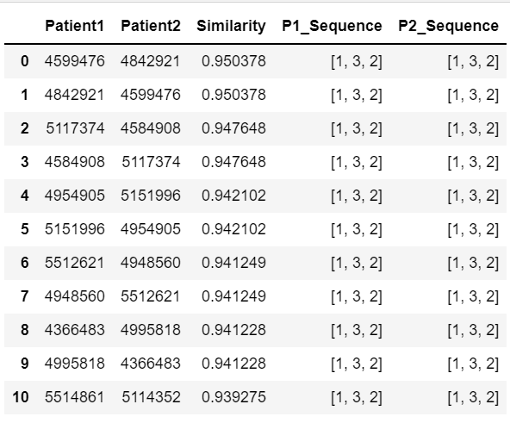

**Centrality measures**

**1. PAGE RANK**

Identifies the procedures with highest usage using the page rank methodology.

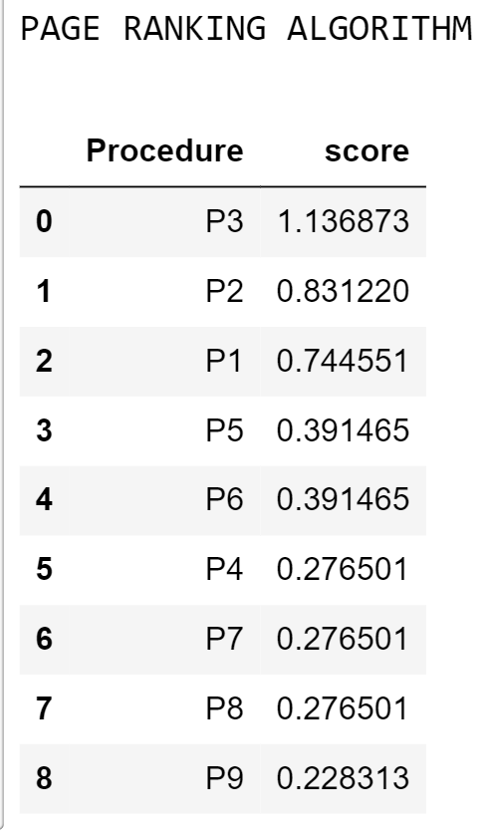

**2. CLOSENESS CENTRALITY**

Closeness centralityis a way of detecting nodes that are able to spread information very efficiently through a graph.

Nodes with a high closeness score have the shortest distances to all other nodes.

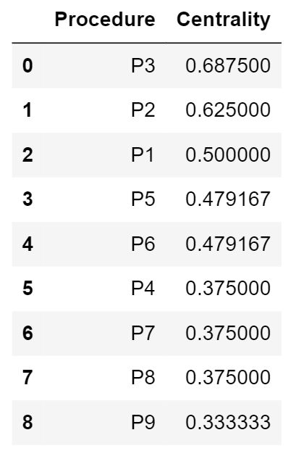

**HITS (Hyperlink-Induced Topic Search)**

HITS is a link analysis algorithm that rates nodes based on two scores, a hub score and an authority score.

The **authority score** estimates the importance of the node within the network.

The **hub score** estimates the value of its relationships to other nodes.

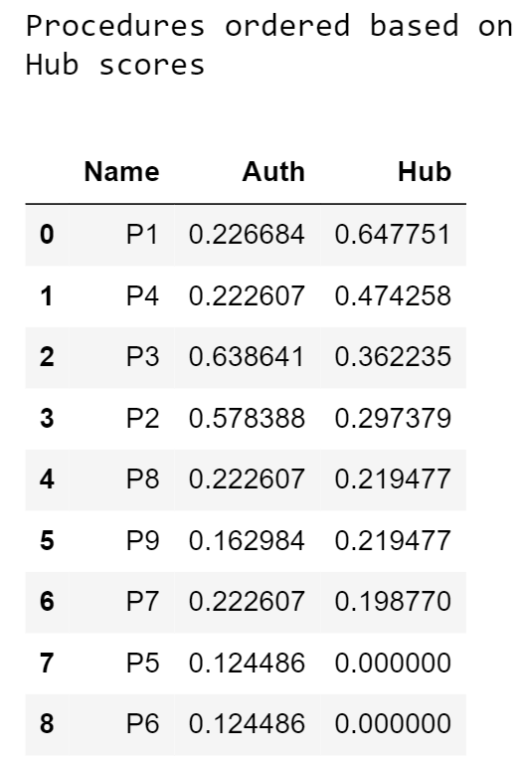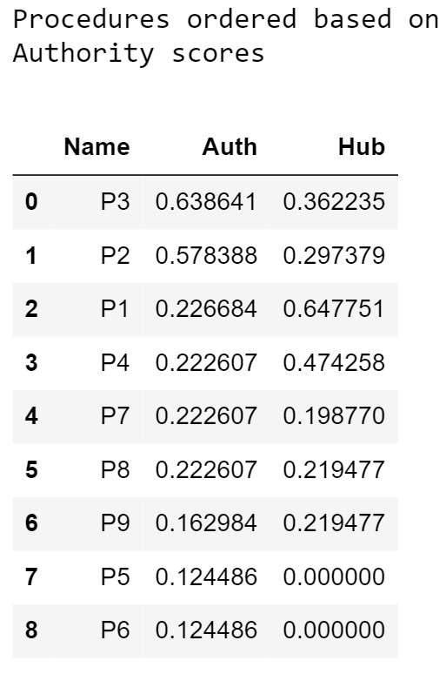

**Link prediction** with help of association rule mining:

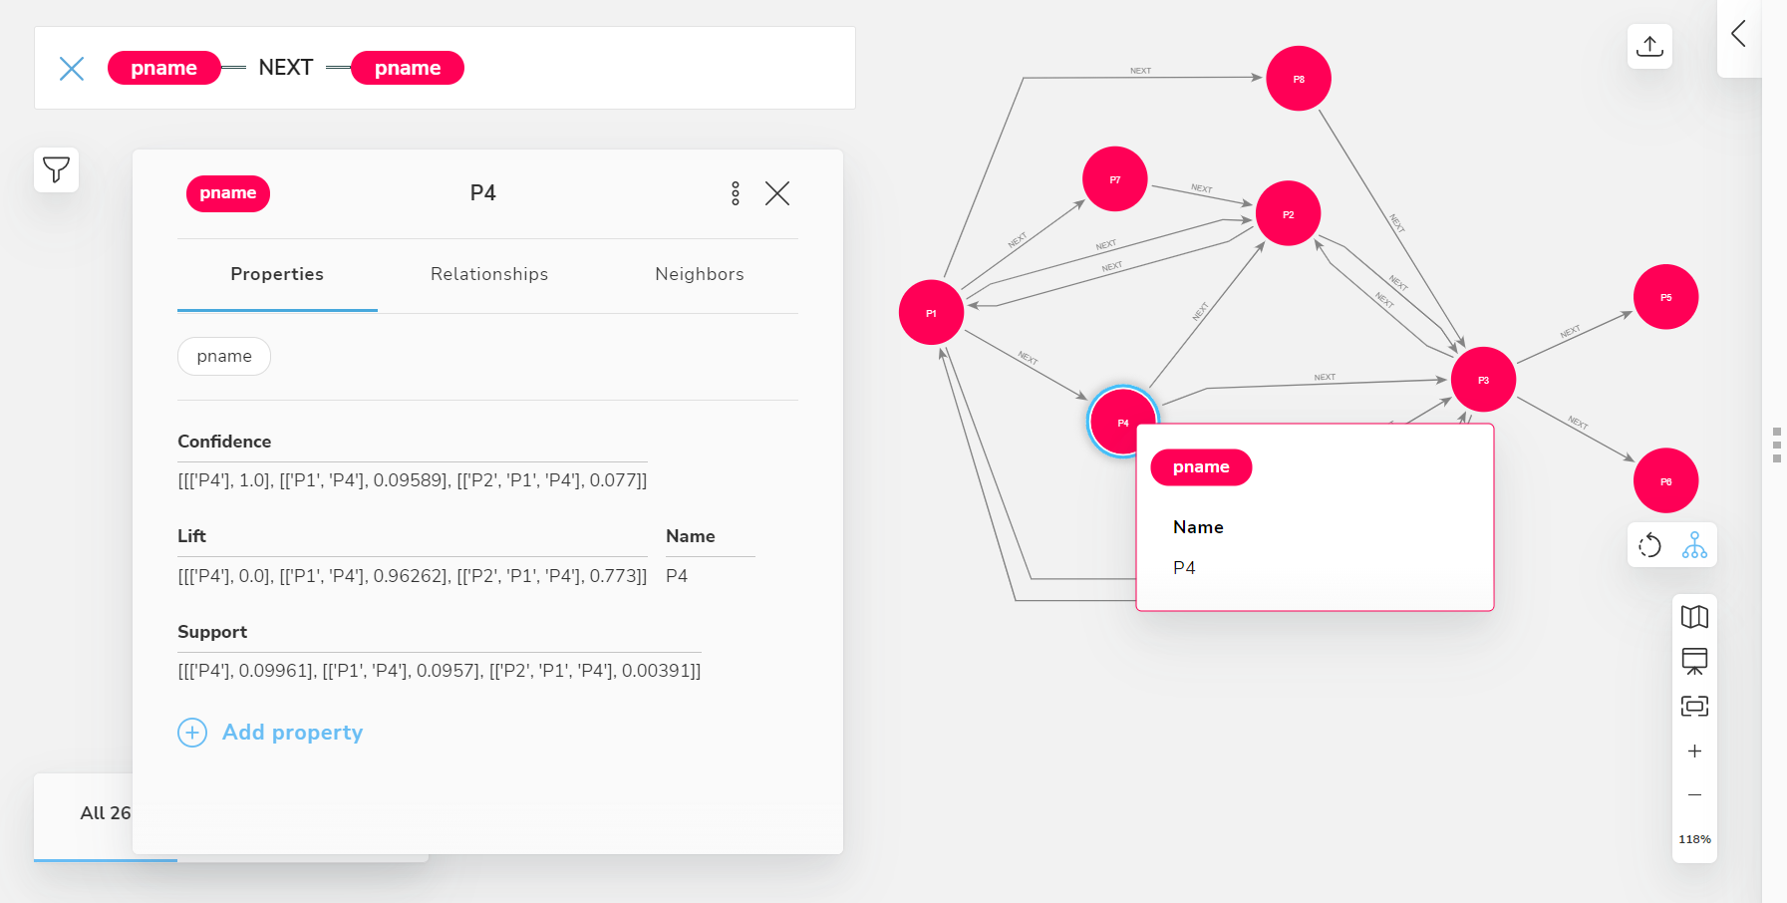

Based on the metrics such as Support , Confidence and Lift , we can proceed to next procedure.

